System Requirement Specification

Orthodontist

April 2021

Version 1.0



Version History

Date | Version  Number | Updated by | Remarks
24-03-2021 | V 01 | Rudhramurthy/  Shanmugham | Initial Draft

Index

1 | Introduction
2 | Objective
3 | Modules of the Project
4 | Data Flow Diagram
5 | Application Development Environment
6 | Architecture
7 | Hardware and Software Requirement  (with Network architecture)
8 | Assumptions
9 | Risks

Purpose
Purpose of the System Requirement document is to describe the design and the architecture of the proposed project. The basic design of the project is expressed in sufficient detail so as to enable all the developers to understand the functionality and underlying architecture of the project.

Target Audience
This Design document is intended to act as a technical reference tool for developers involved in the development of this project. This document assumes that the readers of the document have sufficient understanding of the major technology concepts.
Note: This Document is intended for developers and client, but not for end-users.

1. Introduction
B2C Portal, where any one can use Dr’s lab services online

2. Objective
To provide the Doctors best orthodontist lab service, track the workorder provided by the lab
3. Modules of the Project

The Program Modules that are to be tested are identified as follows:

S.No | Module
1 | Home Page for Portal
2 | Registration : Doctor, Lab Users
3 | User and Role Administration
4 | Login
5 | Patient Registration & Management
6 | Product Order form for doctors
7 | Order Workflow
8 | Order search
9 | Dashboard
10 | Reports (TBD)
11 | Payments Integration (TBD)
12 | Inventory Integration (TBD)
12 | Assumptions
13 | Risks
14

Home Page for Portal
Home page will be website home page when the URL is entered in the browser.
Home will contain links to the login, Doctor’s/Lab’s registration. Other links and content related to the website will be discussed with the client and accordingly the pages will be designed. Ex: contact us, about us etc.,
Note: Portal home page content will be provided by the client for all pages.

Registration
Any user (Doctors/Lab) wishes to use the services of the portal can register, based on the authenticity checks and validations by the admin of portal, the user should be able to login and access product information.
For portal admin and users, they will have regular access according to their entitlement.

User and Role Administration
Admin of the portal will be providing/controlling required access given to any users, be it doctor or lab users. Admin should be able to revoke access to any users as required.

Login
Any Registered and approved/validated users with the portal should be able to login to the portal, login will be handled securely. Based on the user login entitlement the functional access will be controlled

Patient Registration & Management
After successful login, the Doctor can register their patients with patient’s details.
The portal provides the Doctor to manage the patient’s details. Individual patient’s’ details are managed w.r.t their personal & dental observations.

Product Order form for doctors
For any given patient, Doctor would be able to capture patient’s dental images and video files which would later be sent to the labs for making products. Order form to place orders can be captured in a systematic way, any other information related to fulfill order placement will also be captured here. Doctors can have a view of images/video associated with the given patient and place order to the lab. Once order placed, status of order can be tracked by Doctors, admin & lab users.

Order Workflow
Any order once received from Doctor to the lab undergoes series of steps until order is delivered to the clients(doctors). This process can be automated and systemised so that effective tracking and stages of the order can be tracked real-time.

Once Lab receives the order, the product is made and snapshot (as image or other format) and is sent back to Doctor for final product approvals. The back & forth communication between Lab & Doctor for the given order/patient would be tracked properly till fulfillment and notified to all stakeholders i.e Lab/Doctor/Admin during the due course of product life cycle.
Admin should be able to view the status of the received orders and their corresponding status. This adds value of measuring performance of an order fulfillment and can be projected as a report and can be effective in increasing throughput. This also makes admin knows where the product is stuck in order workflow at any given point of time. Various feature for workflow can be added during due diligence.

Order Search
Search can be categorized for orders by admin, lab users and doctors and for admin for searching registered users, the searched items should be navigable and display relevant form with information.

Dashboard
Once login completed, a Dashboard of various portal feature with relevant data can be displayed for a quick action and navigation for the logged in users. The dashboard will be different according to the application user i.e admin/Doctor/Lab user

Reports – (TBD)
Required reports for daily tasks and admin purpose can be discussed and arrived, based on this we will update the reports section post due diligence

Payments Integration (TBD)
Online payment can be integrated based on client interest and relevance to the requirement, viable options will be proposed post due diligence.

Inventory Integration (TBD)
From Product perspective, the inventory associated for making the products also need to be managed. Proposed during initial discussion. viable options will be proposed post due diligence.

4. Data Flow Diagram
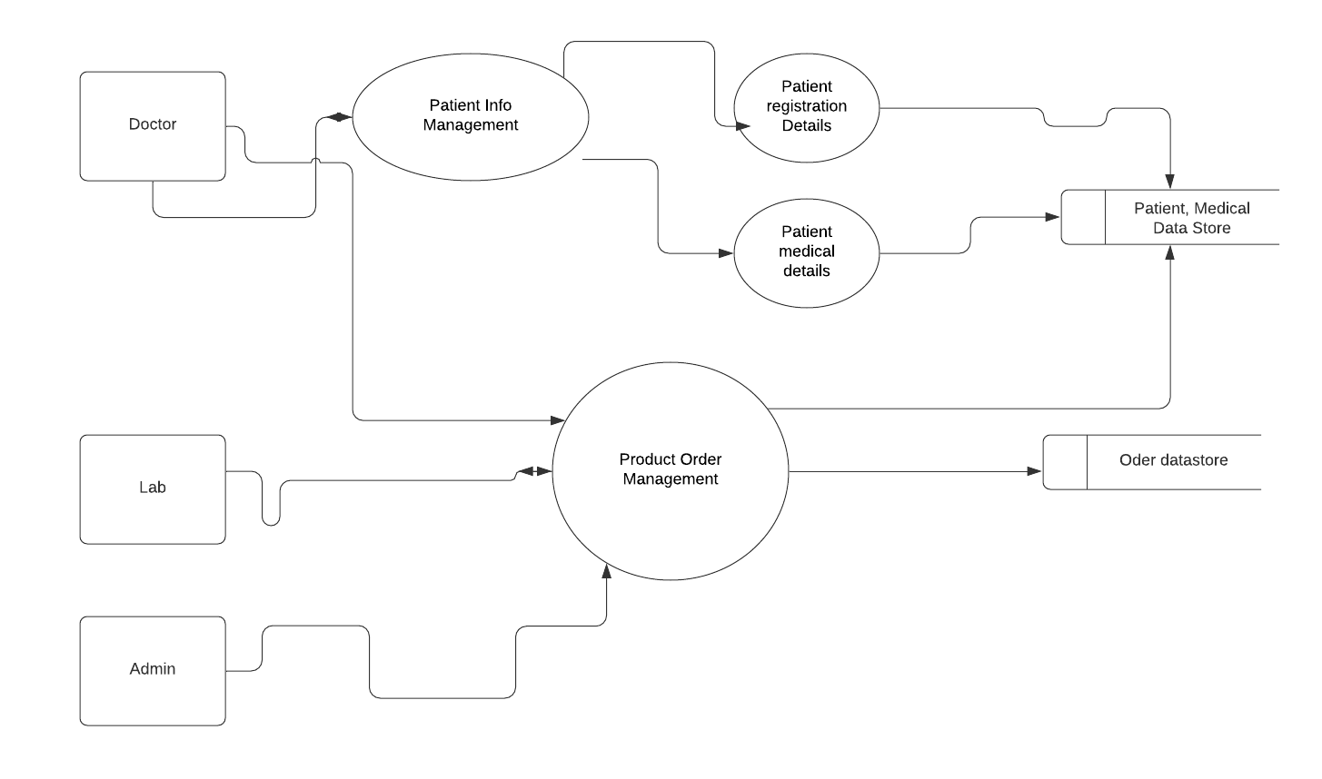

6. APPLICATION ENVIRONMENT - TECHNICAL ARCHITECTURE

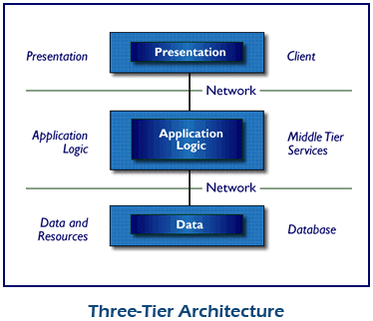
Architecture depicts the overall structure of a System. It considers the overall functioning of the system. It may consist of one or more subsystems, which interfaces with other subsystem to provide a final version of System. Issues related to scalability, security, portability of the System will also be analysed under Architecture. Implementation details will not be covered under architecture.

The three-tier architecture helps in hiding all the business rules inside the Spring framework and thus business logic will not be exposed to outside world. The maintenance becomes easy since any changes to the middle tier or the front end does not involve any changes in the back-end database design. Also, the scalability of Database server increases as the Postgres server acts only as a data store and does not have any load to do any computation and it can be within the same box with the web server.

7. ARCHITECTURE - Web based application

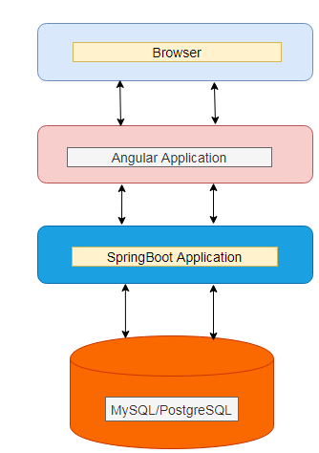

Sample Network Architecture

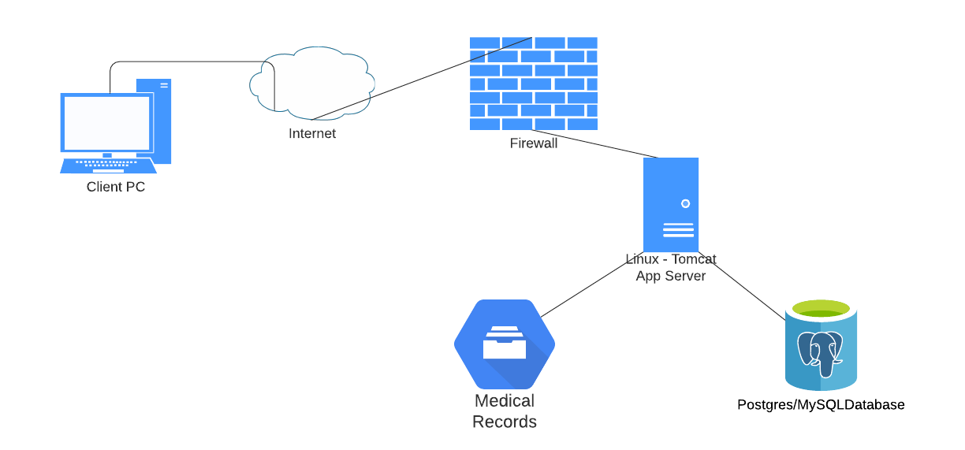

11. Assumptions

The following points requires the client’s discussion during due diligence

a – There will be only one lab to cater services to the ‘N’ number of registered Doctors

b – The workflow sequence and intermediate communication between the Doctor’s/Lab/Admin

c – The patient’s medical details i.e image and video file details and the max limit

d – The lab’s product related image or video file details and the max limit

e - The Doctor registration/Patient’s registration details

f – The Max/Min/Average/Peek user access to the system/day

g – The data purging & archive policy

12. Risks

SYSTEM REQUIREMENTS SPECIFICATION
for
Application Name
Coordination/Approval

Submitted by :
Reviewed by (no signature required) :

Approved by :

